**Write a C program that generates a sequence of prime numbers within a given range using nested loops.**

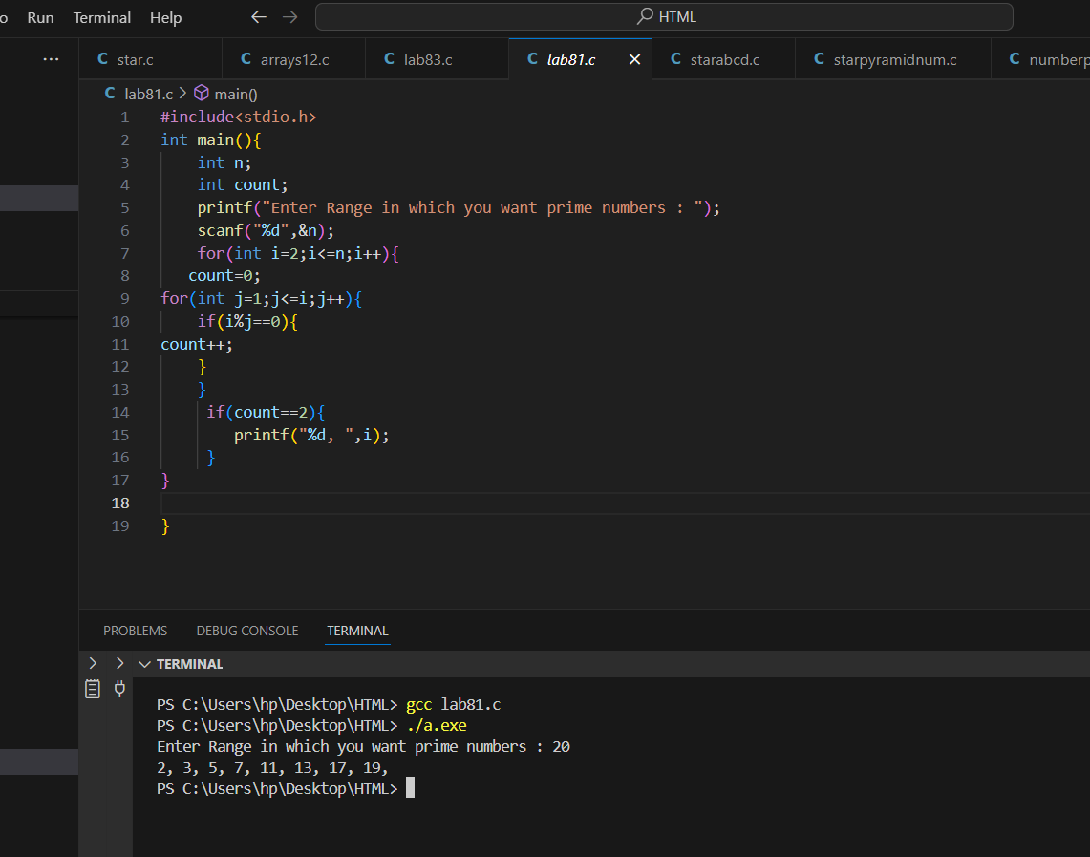

**Generate a pattern of odd numbers in decreasing order starting from a user-specified number using nested loops.**

**Write a C program to find the saddle point(s) in a given 3x3 matrix. A saddle point is an element that is the smallest in its row and the largest in its column.**

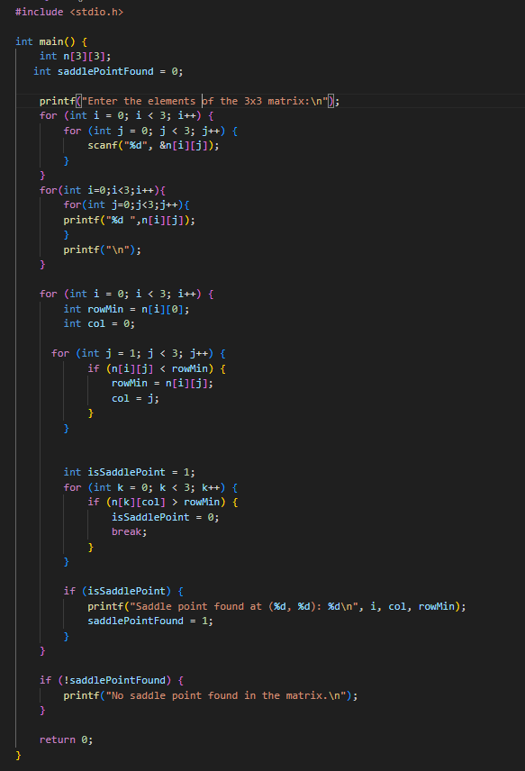

**Write a C program to multiply two matrices of size 3x3 and display the result matrix.**

**Write a C program to generate a diamond shape pattern using nested loops. The program should take the number of rows for the upper half of the diamond as input from the user.**

